ZARA

UI&UX DESIGN

**Cohort:** BSE21BFT3

**Assigned by**:

Mr Ramwodin Loovesh

**Done by**:

Sesungkur Keshini: 2110_22847

Sooumbur Keerty: 2110_22852

Ujoodha Lovena: 2110_22856

Veeraragoo Ishwari: 2110_22858

17 Feb

2023

Table of Contents

Summary 3

Project Overview 4

Moodboard 5

Style Guide 6

**Font** 6

**Color Palette** 6

**Logo** 6

**Typography Guidelines** 7

**Iconography** 8

Model Hierarchical/ Sitemap 9

Gantt Chart 9

Redesign Recommendations 10

Wireframe 11

**Homepage Wireframe (Desktop and mobile phone)** 11

**Navigation Wireframe (Desktop and mobile phone)** 12

**Product Page Wireframe (Desktop & Mobile)** 14

**Cart Wireframe (Desktop & Mobile)** 16

**View Product Page Wireframe (Desktop & Mobile)** 19

Mockup 20

**Homepage Mockup (Desktop and Mobile phone)** 20

**Navigation Mockup (Desktop and Mobile phone)** 21

**Product page Mockup (Desktop & Mobile)** 22

**Cart Mockup (Desktop & Mobile)** 23

**View Product page Mockup (Desktop & Mobile)** 24

Usability Principles 25

➢ **Homepage** 25

➢ **Product Page** 27

➢ **Cart** 29

➢ **View Product Page** 30

# Summary

This report is about the redesign of the ZARA website based on the survey and hypothesis made. Using the recommendation, the ZARA website is we sketch some wireframe for homepage, product page, view product page and cart also design their mock up to amend some critical usability issues.

Standard website usability and design principles such as the color, scale, typography, navigation, iconography, and accessibility are used to make design decision. A hierarchy is used to maps out the various interactions a user will take within the system. The hierarchy begins with the main goal of finding a product and adding it to the cart. Moreover, a Gantt chart is used to show the time taken for each process to complete. Finally, we compare the current pages with the mock up to mention how the application is easy to use now after redesigning the mock up.

# Project Overview

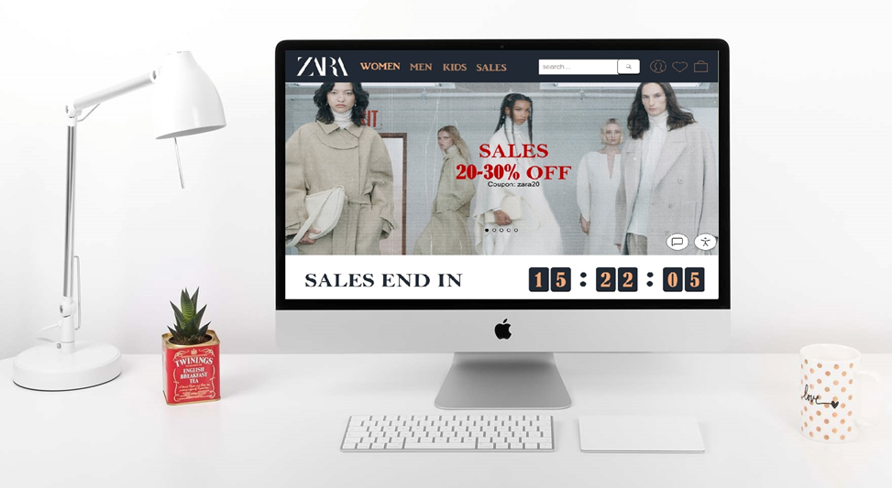

The goal of this project is to improve the online shopping experience for millennials who are interested in fashion by reworking the Zara website. There are several collections available on Zara's current website, whether they are seasonal or not. Every two weeks, the website is updated with the most recent fashion trends. We discovered that the volume of information and the manner it is now presented make it more challenging than necessary to browse, which discourages customers from making online purchases. Their website redesign's primary objective was to reorganize the navigation into a more contemporary and straightforward look. We discovered via study and personal experience that internet customers have trouble believing in businesses that don't have honest and accurate photos and evaluations. Our purpose is to add features to the website that would help Zara customers feel more confident about their online purchases.

# Moodboard

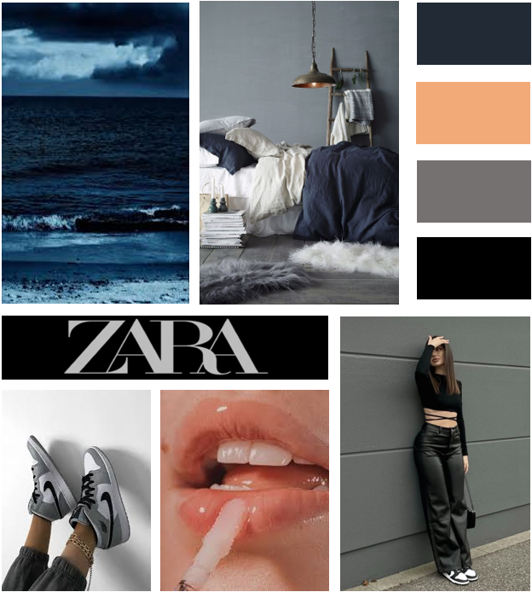

# Style Guide

## **Font**

Header 1

**Header 2**

Footer Header

Footer Text

Body Text

12:34:00

## **Color Palette**

#222A35 #F3AA79 #767171 #000000

   

## **Logo**



## **Typography Guidelines**



## **Iconography**

 Facebook

 TikTok

 Instagram

 Twitter

 Pinterest

 Spotify

 YouTube

 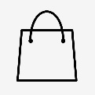  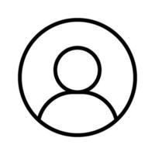

  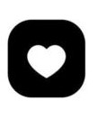

**<**   **>**

 

# Model Hierarchical/ Sitemap

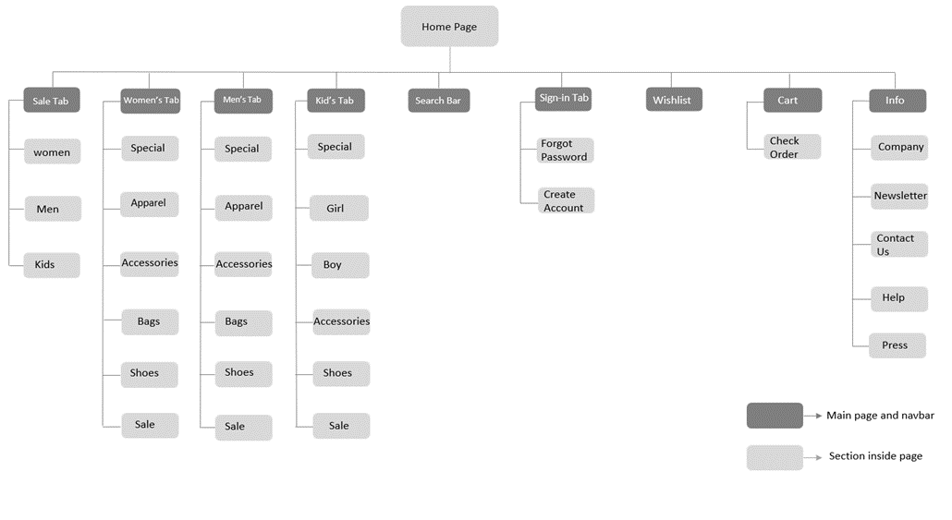

# Gantt Chart

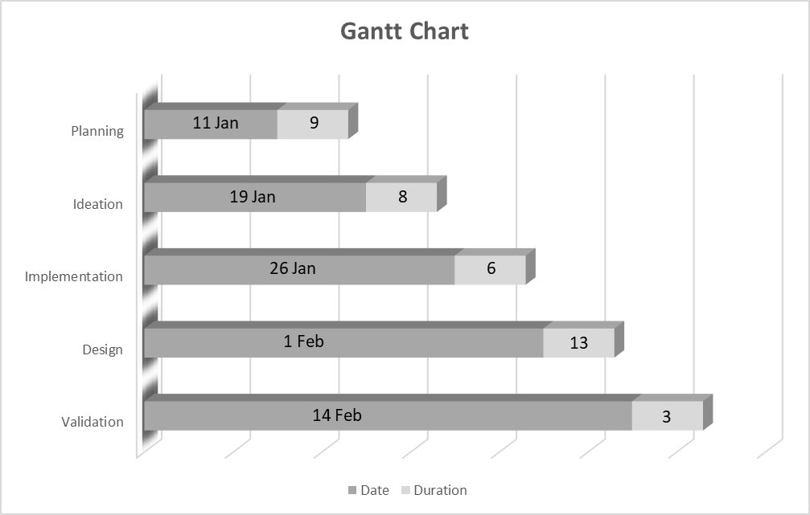

# Redesign Recommendations

The following redesign recommendations are based on all the usability issues that the users faced in terms of user interaction and user experience. Thus, the redesign of the homepage, product page, cart solves all the problems that users mention on the survey made. We design each mockup according to the user’s recommendation like they mentioned before about having a clear view of everything on the page where they does not need to look for minutes about the main features so that they can navigate. These mockup are design in order to make user experience smooth and users are able to use the ZARA website without any difficulties.

Home Page

* Current Homepage

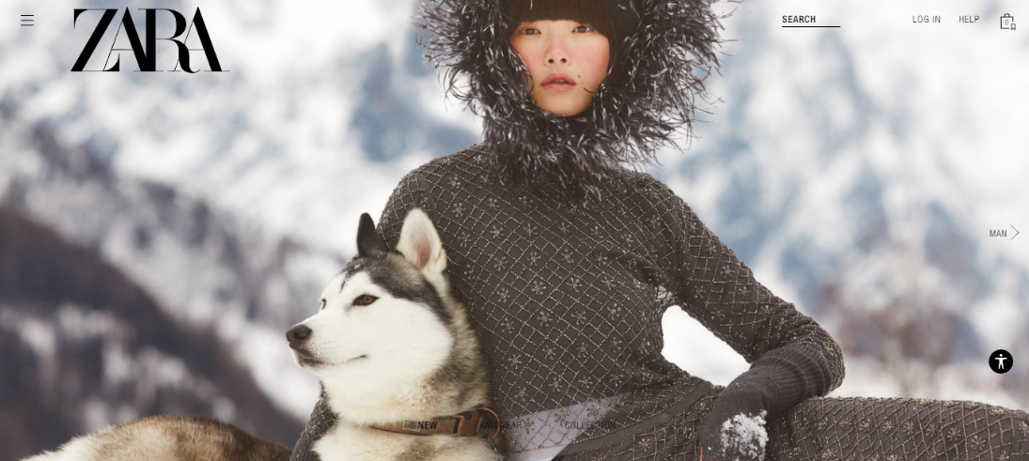

# Wireframe

## **Homepage Wireframe (Desktop and mobile phone)**

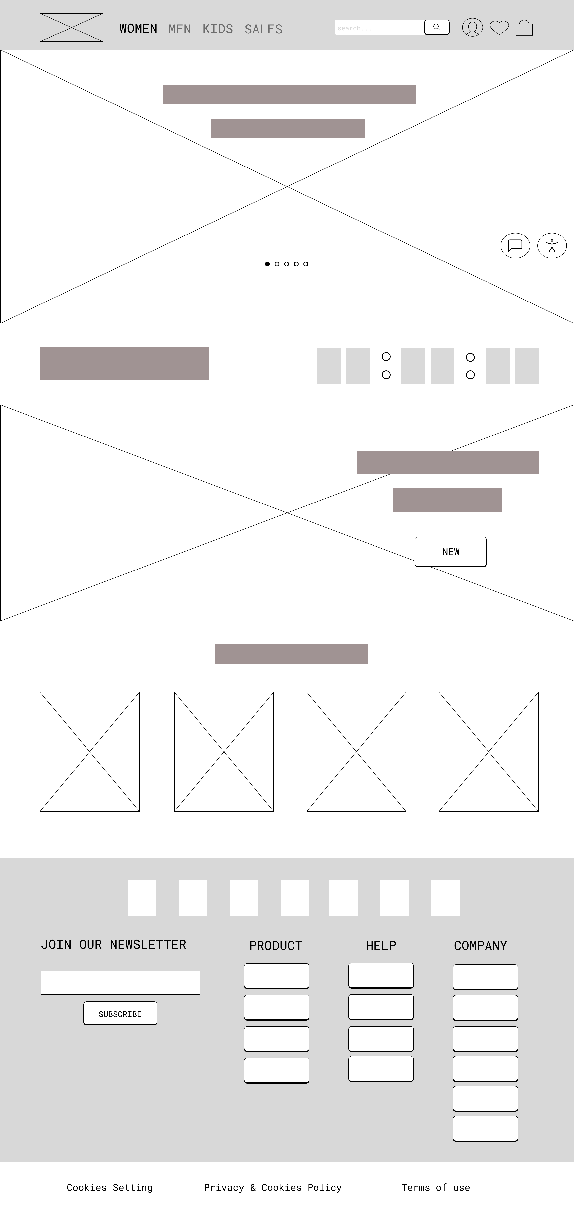 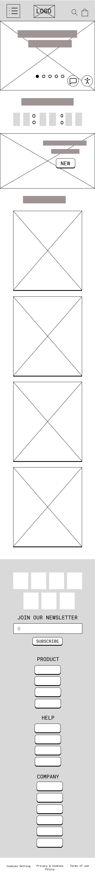

* Current Navigation Menu

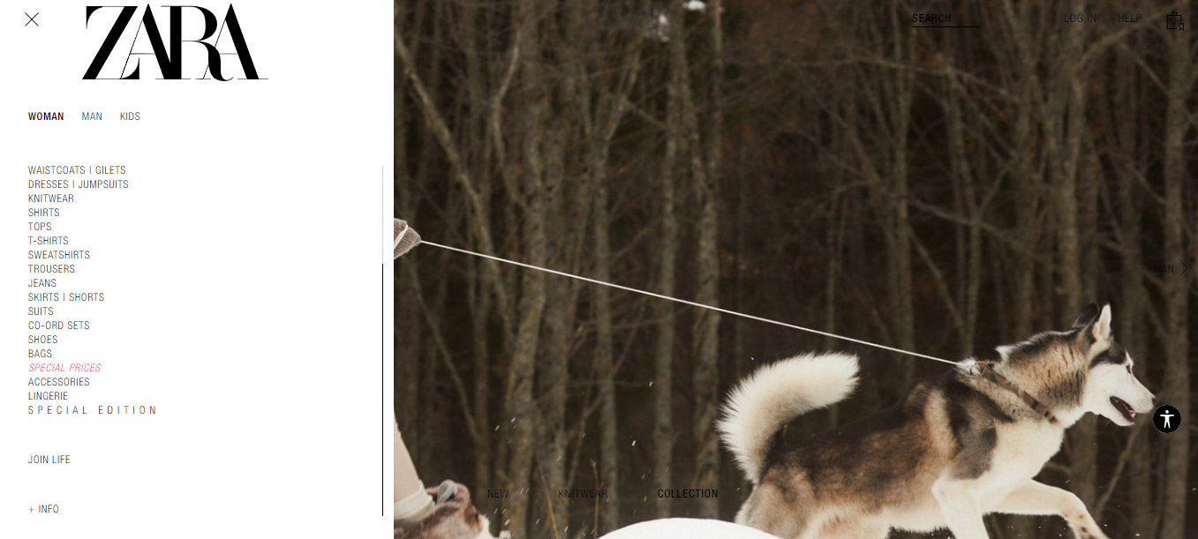

## **Navigation Wireframe (Desktop and mobile phone)**

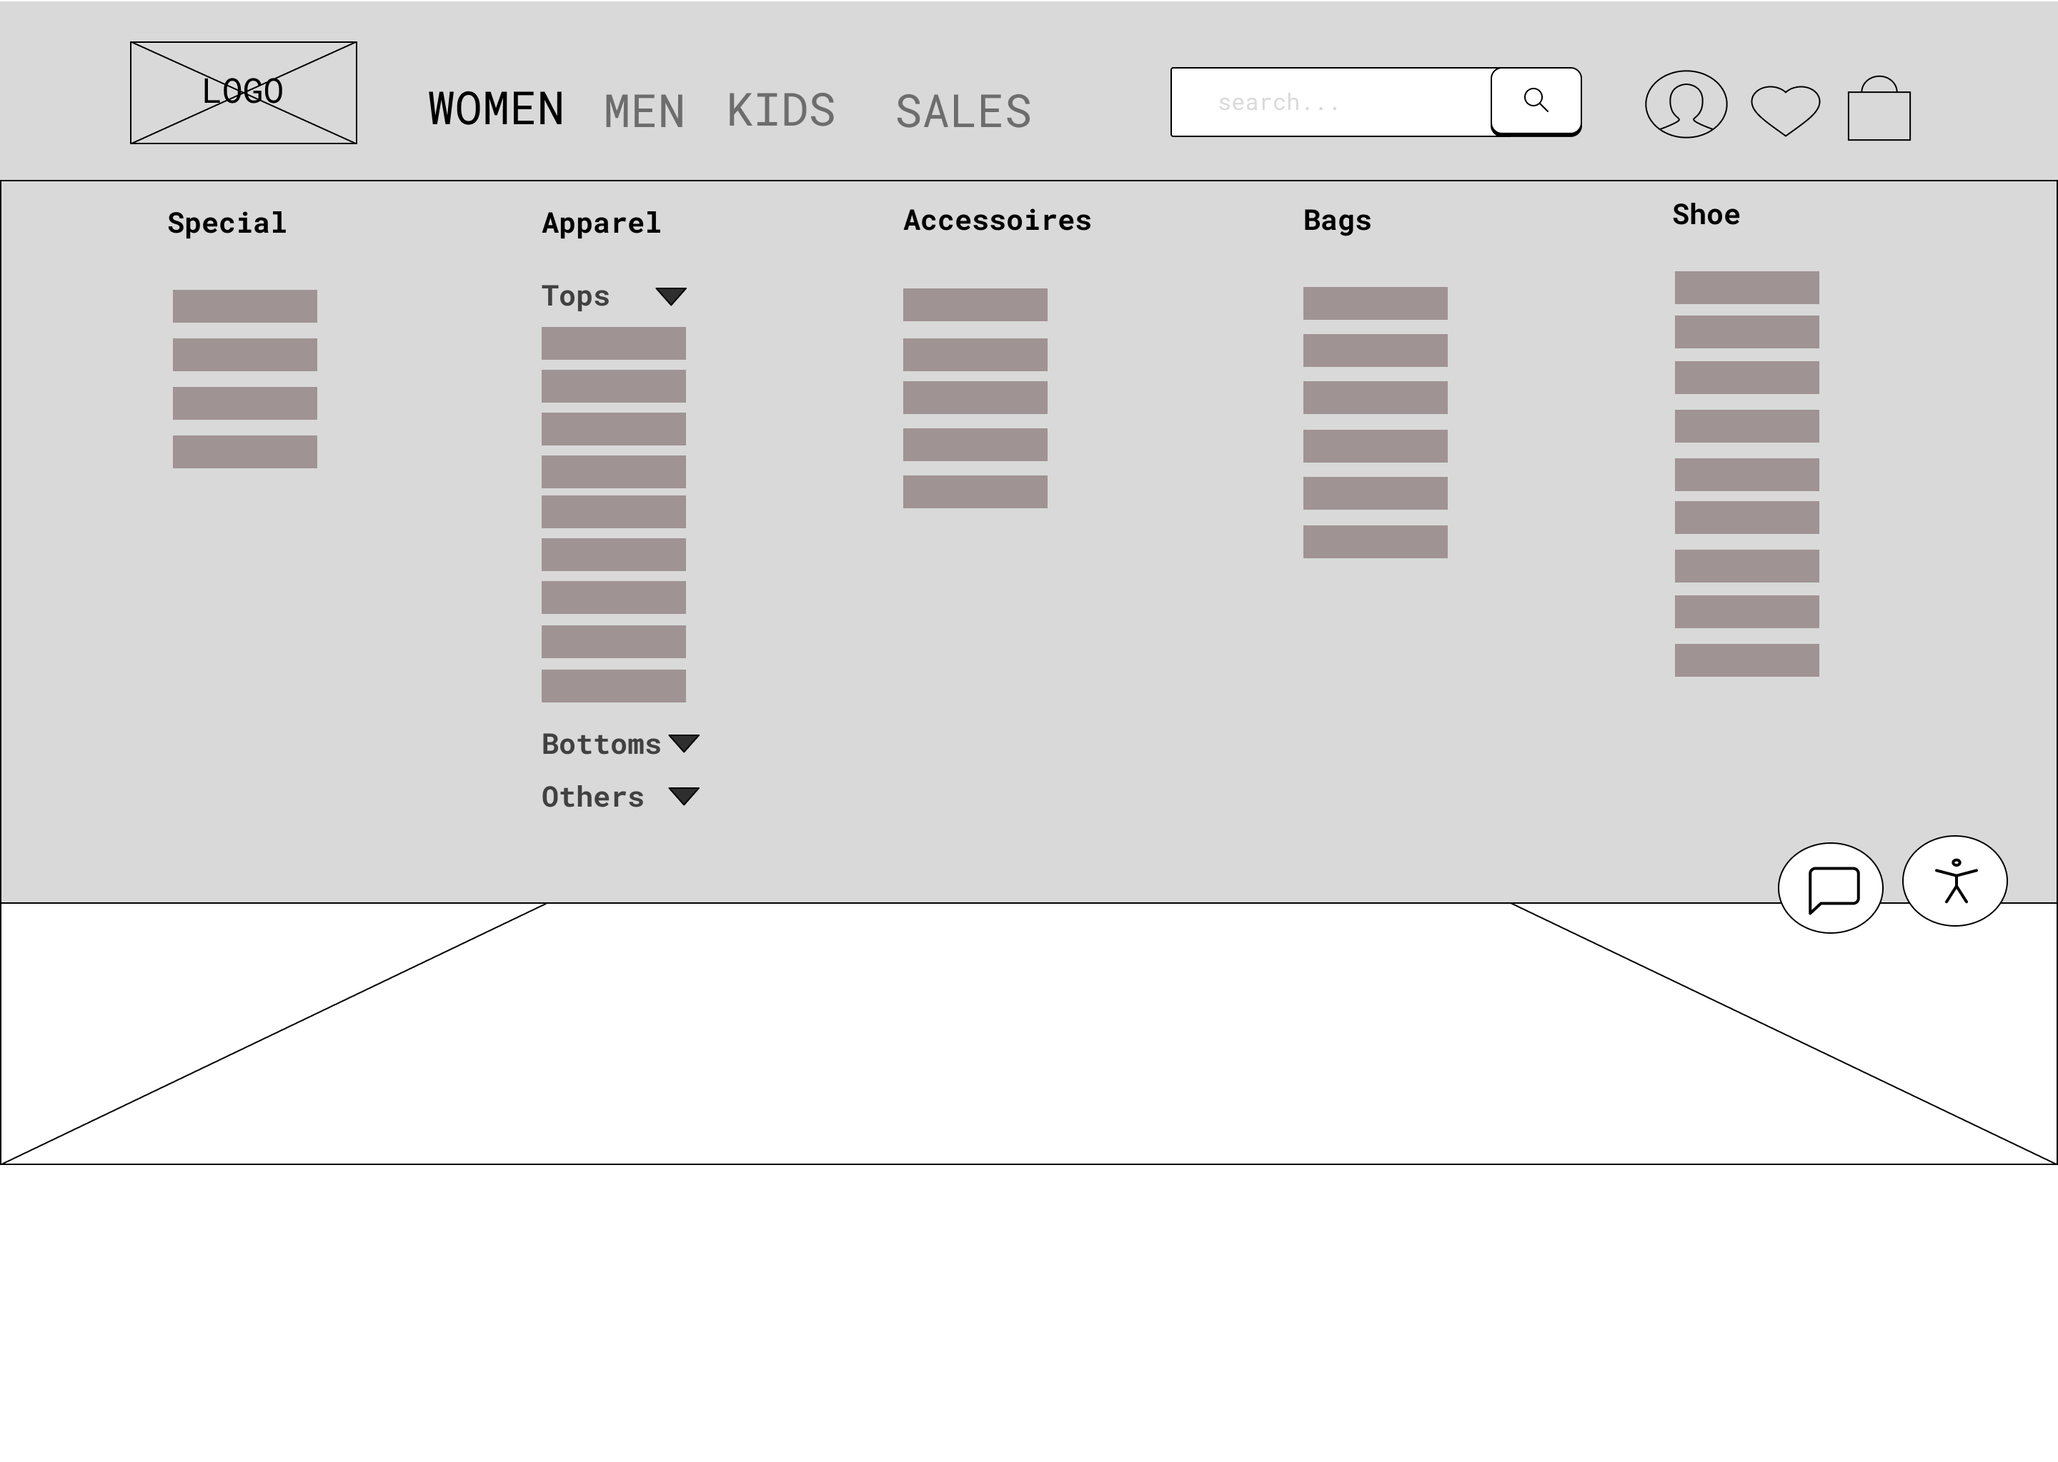

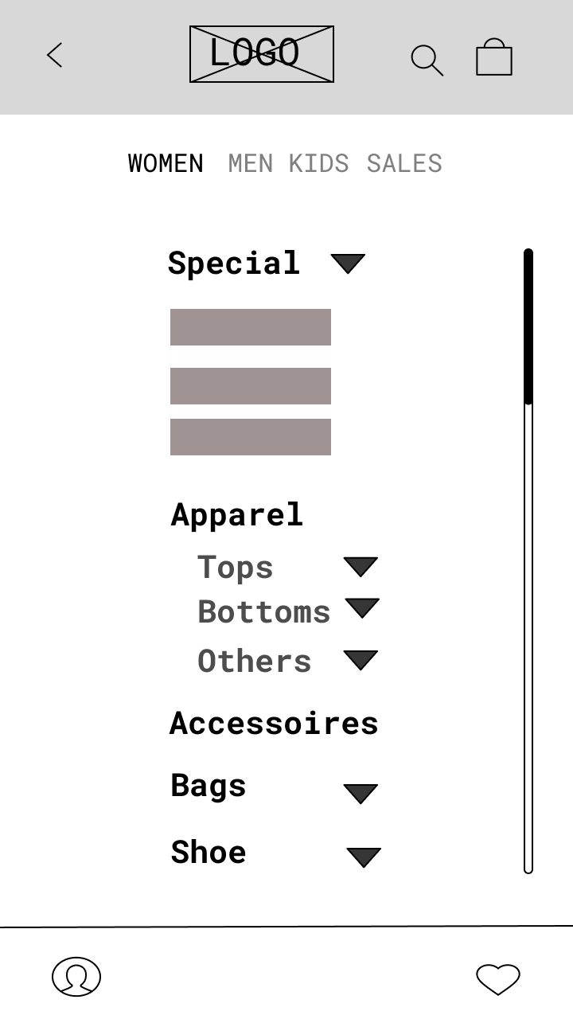

Product Page

* Current Product Page

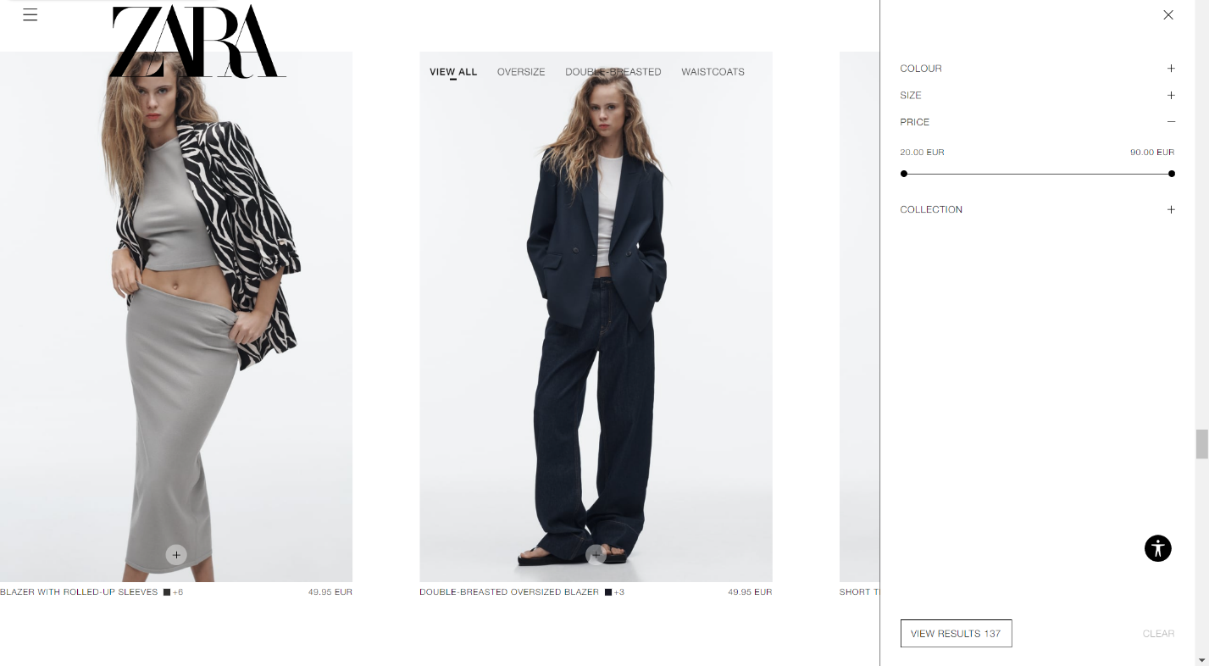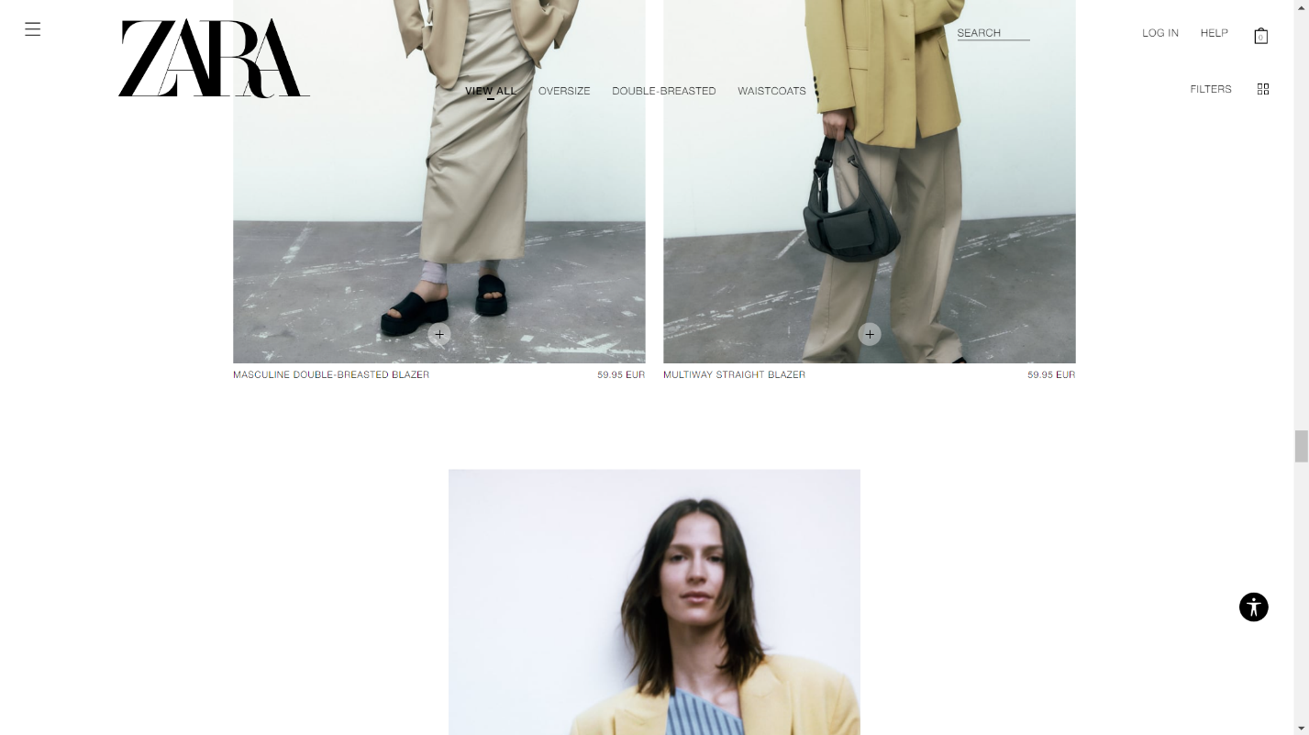

## **Graphical user interface, application Description automatically generatedProduct Page Wireframe (Desktop & Mobile)**

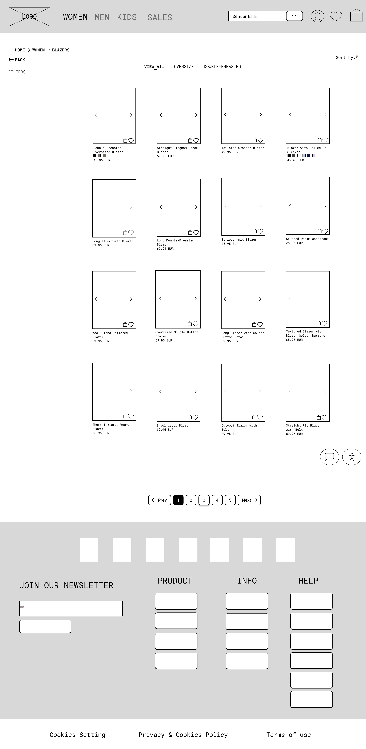

Cart

* Current Cart

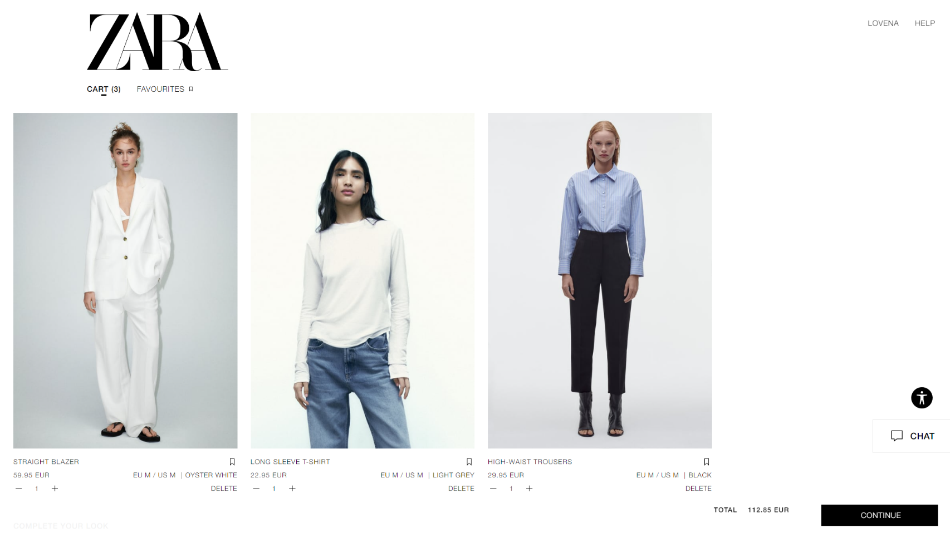

## **Cart Wireframe (Desktop & Mobile)**

Shopping bag

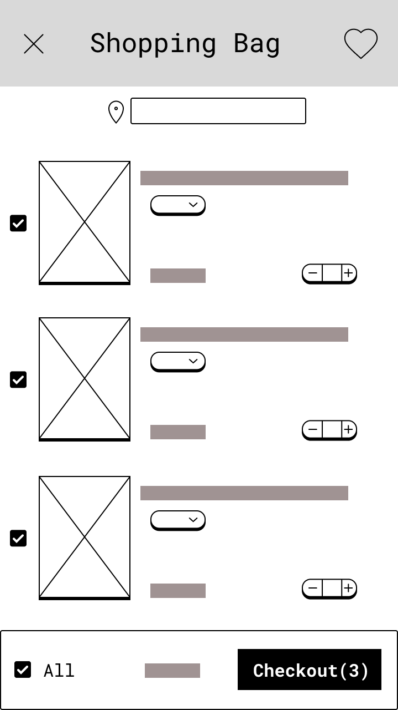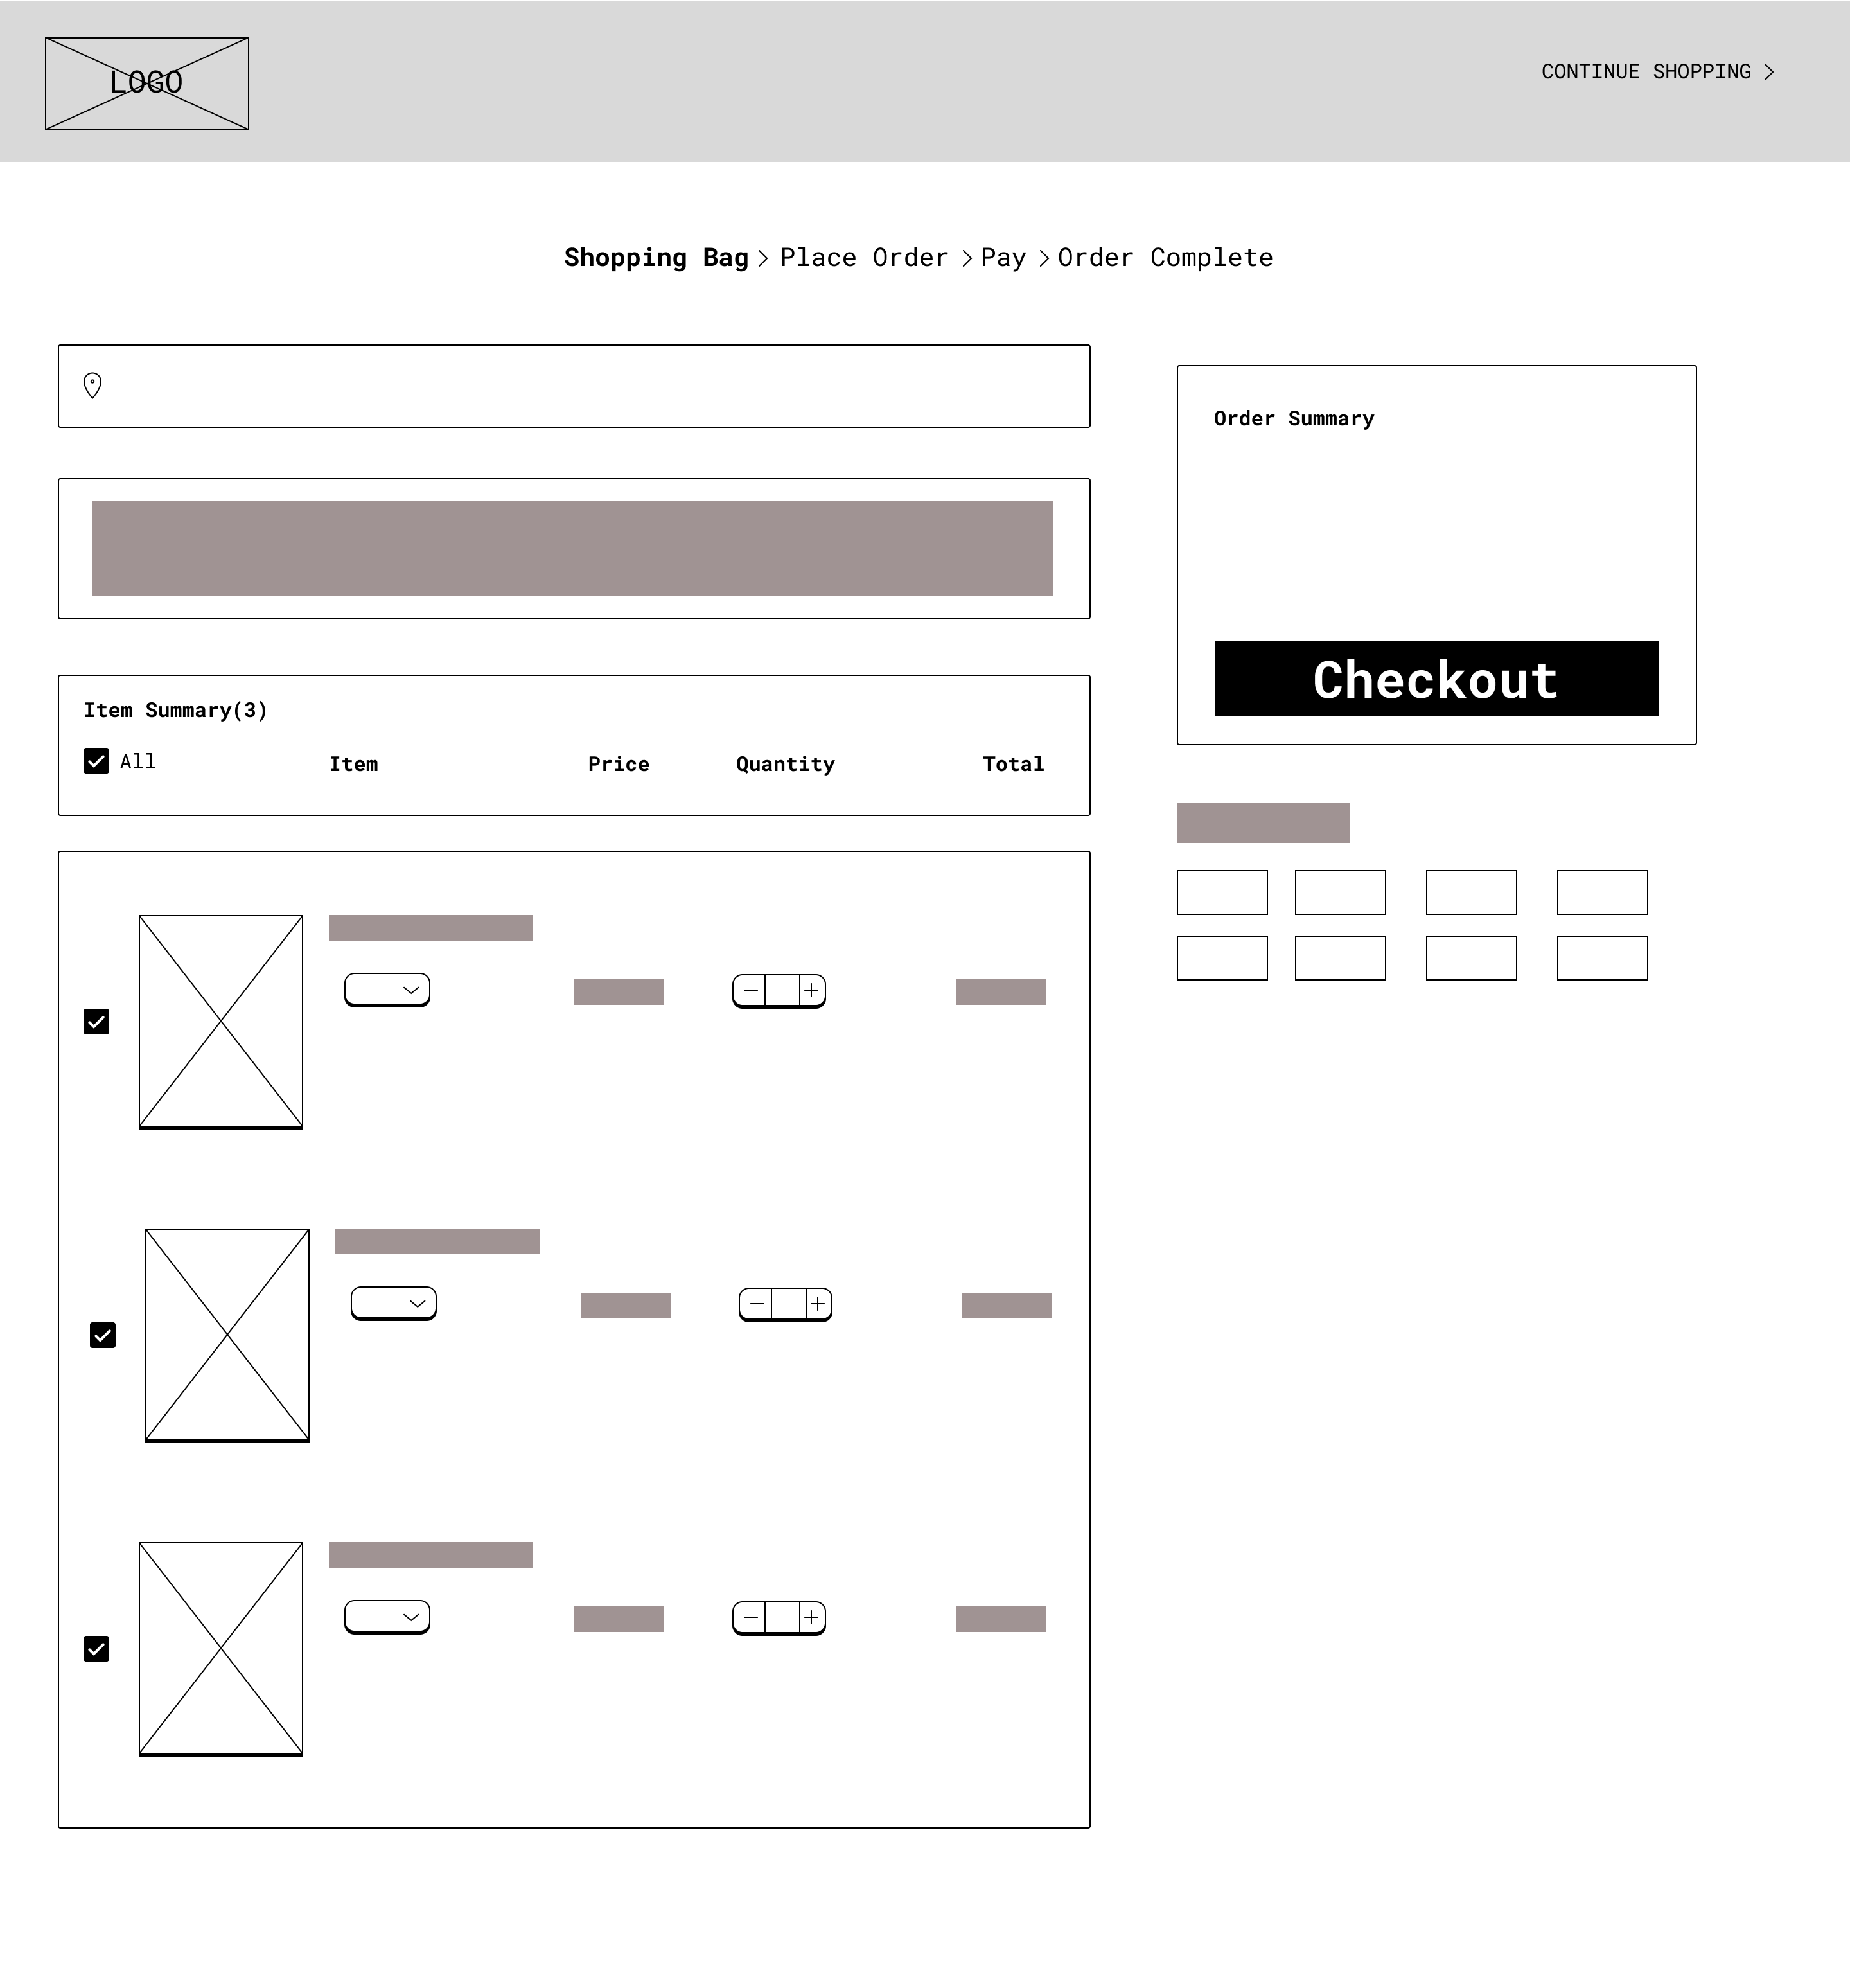

Place Order

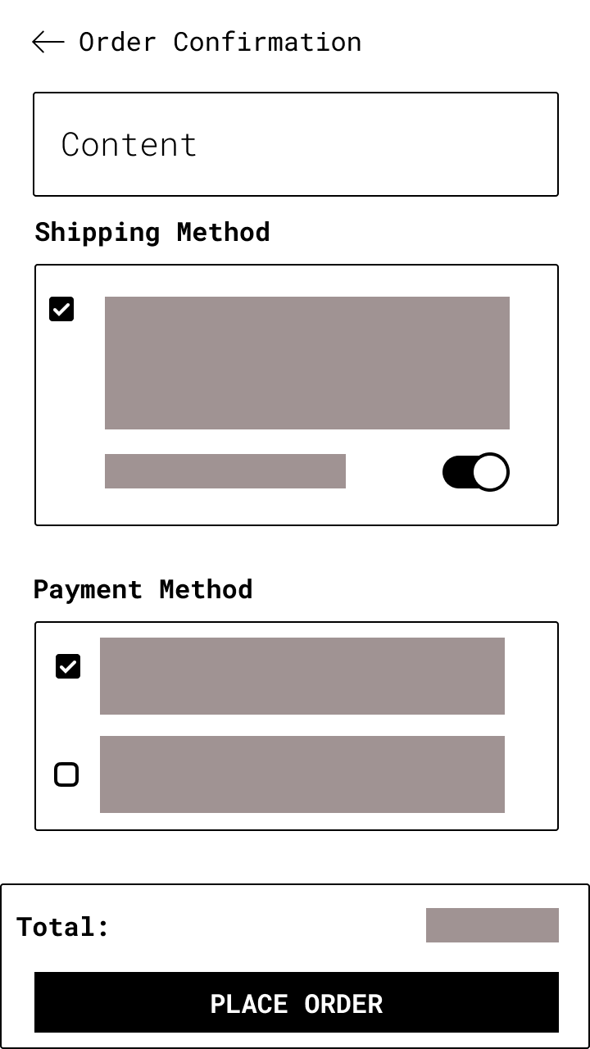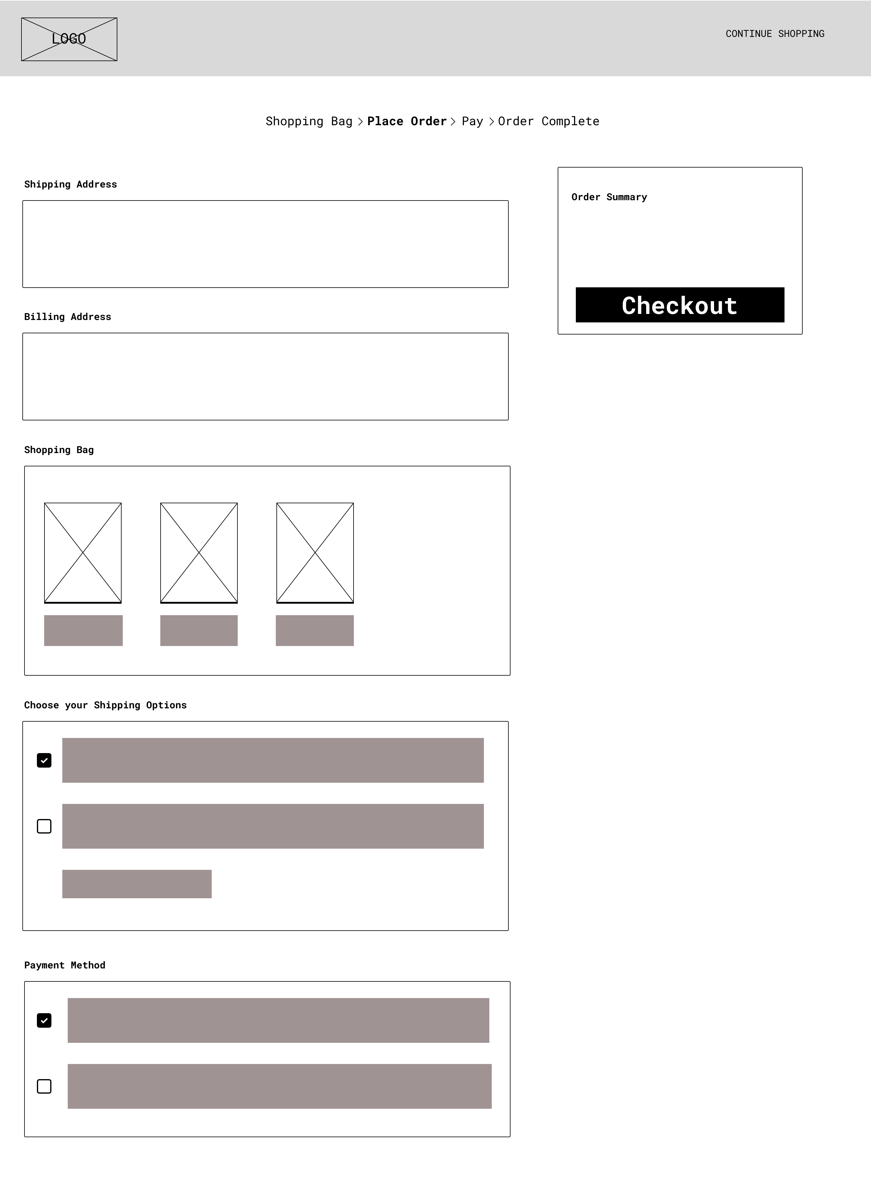

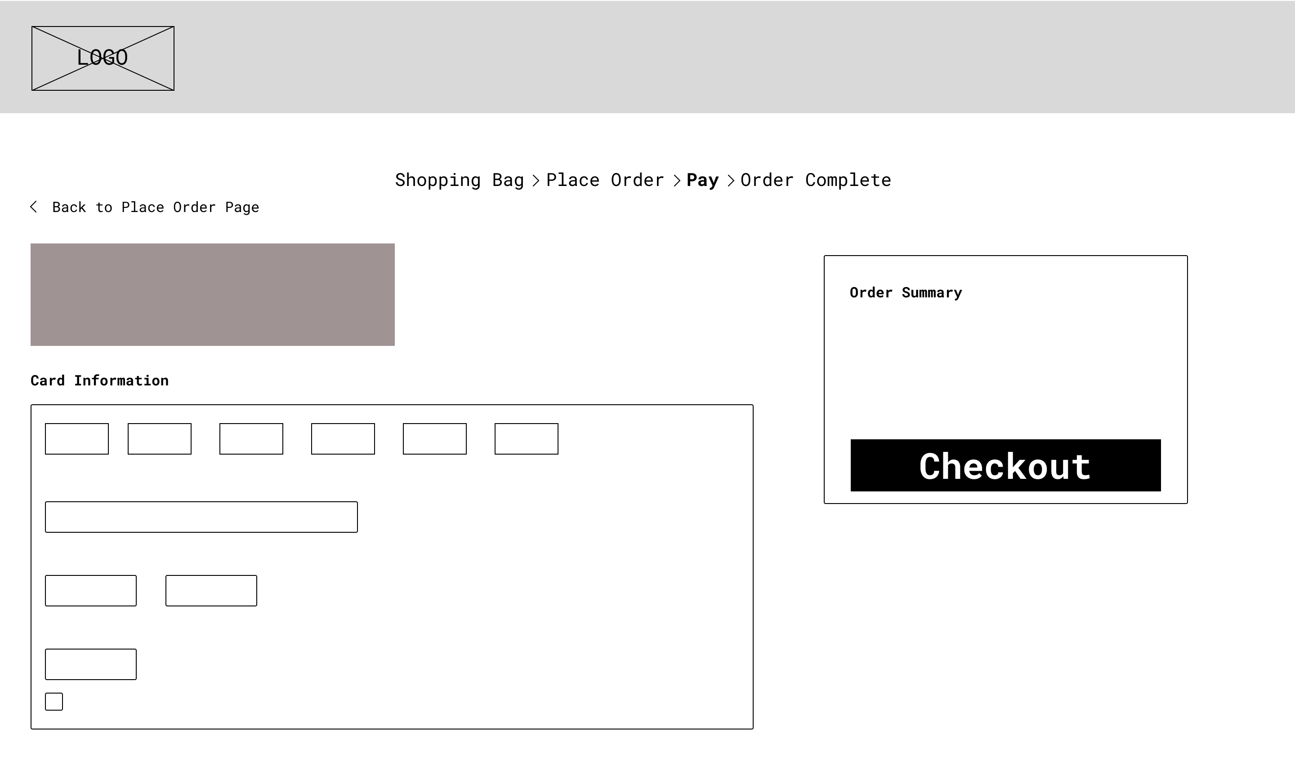Pay

View Product Page

* Current View Product Page

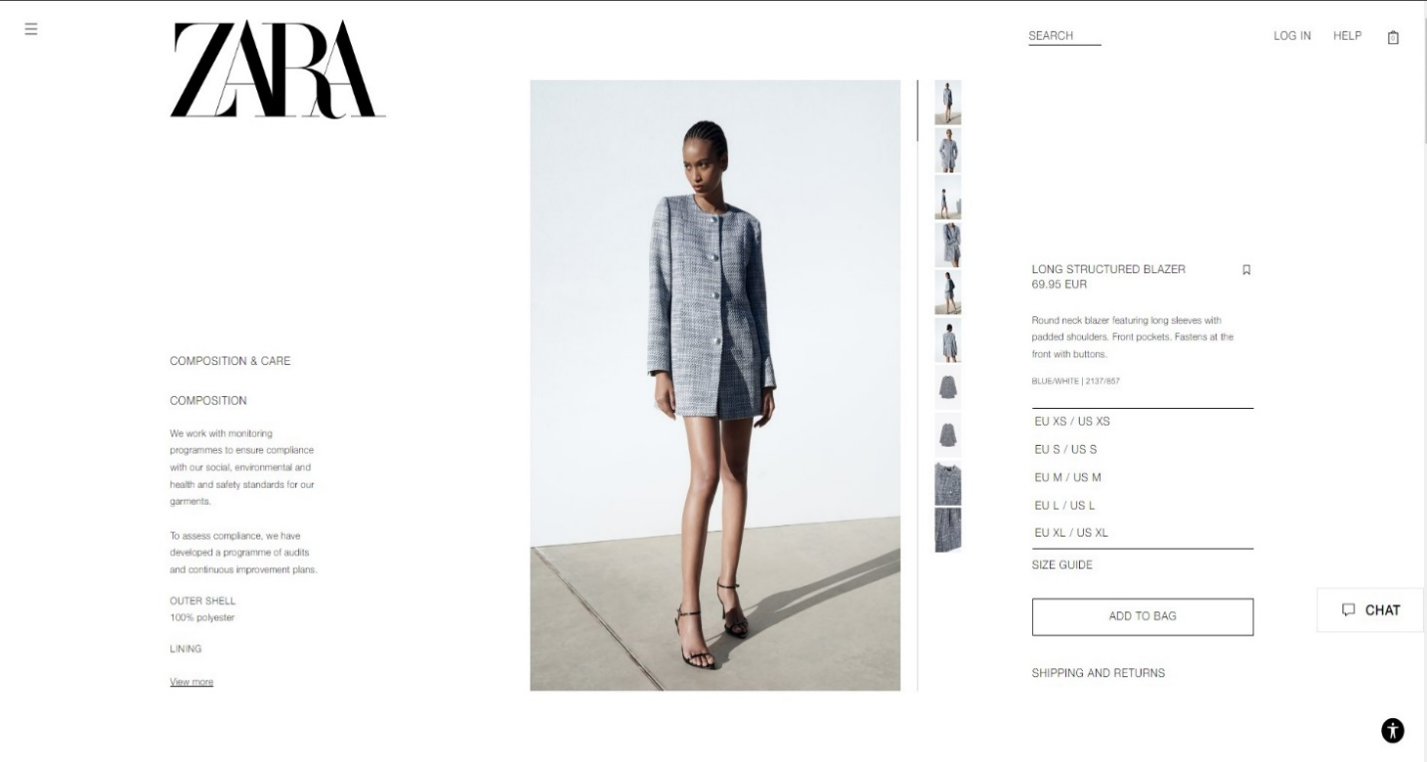

## **View Product Page Wireframe (Desktop & Mobile)**

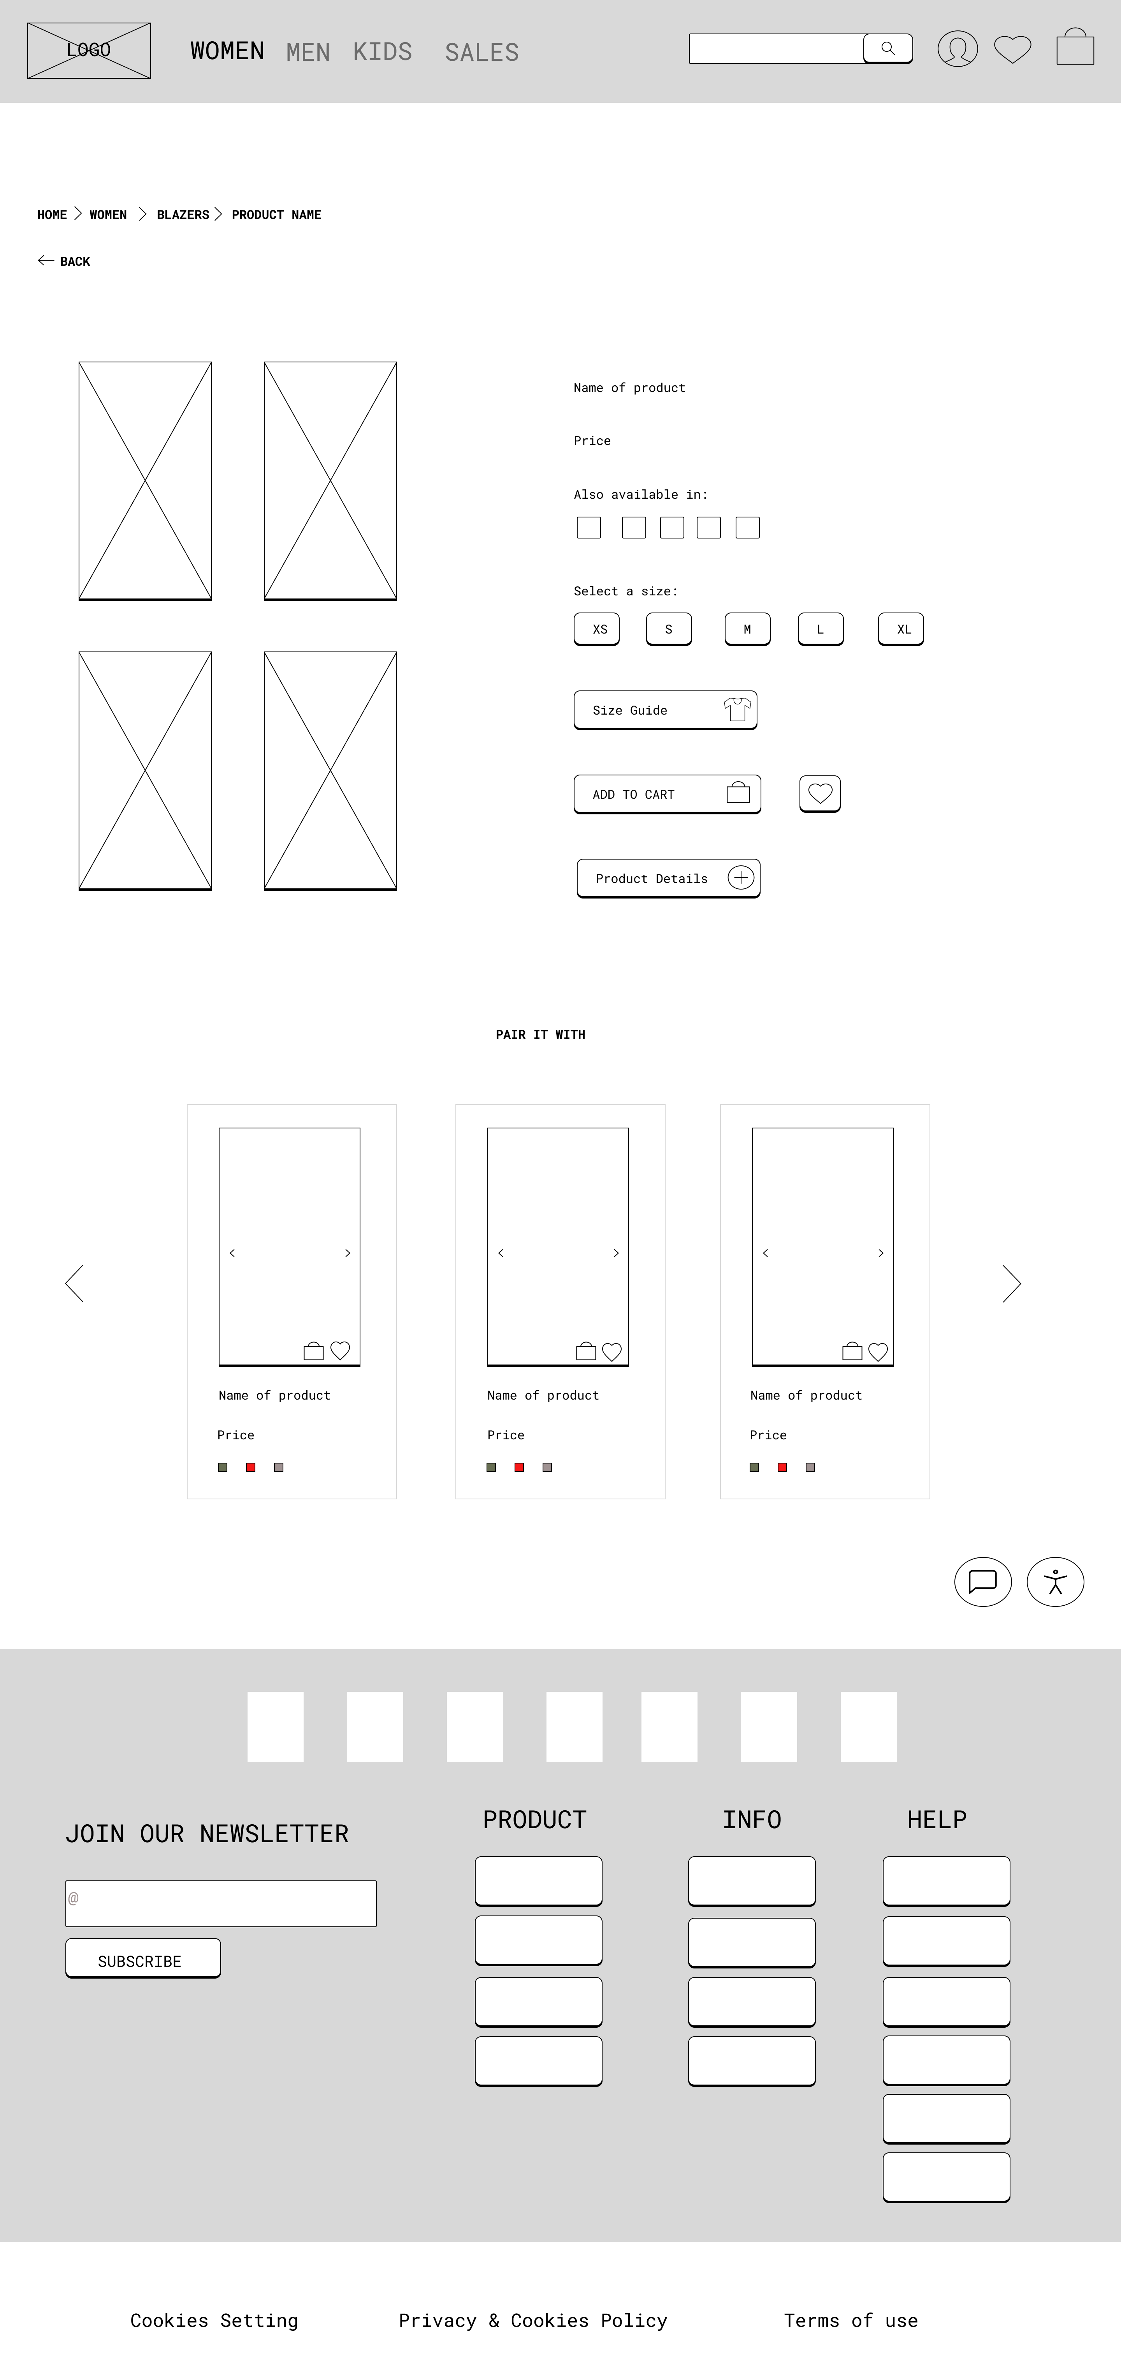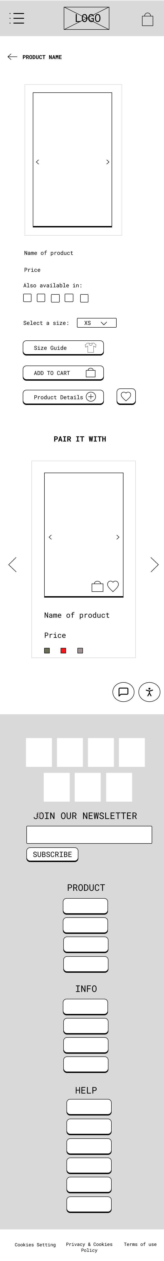

# Mockup

## **Homepage Mockup (Desktop and Mobile phone)**

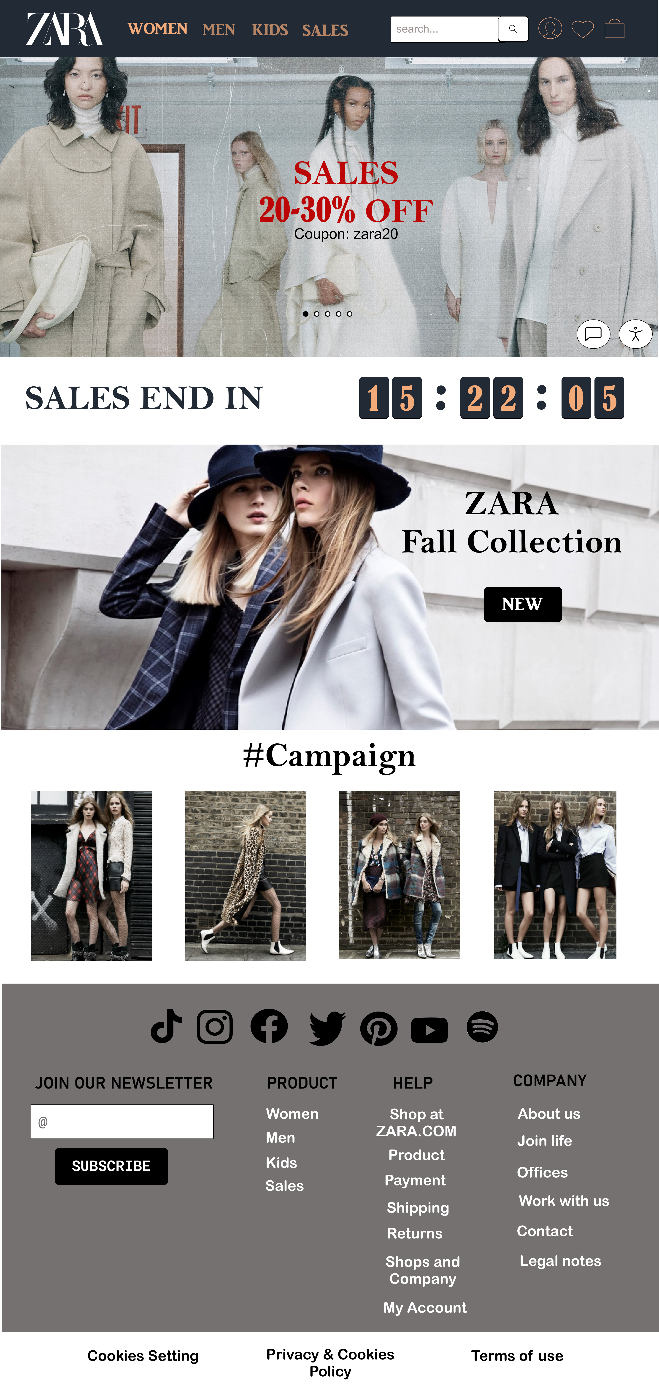 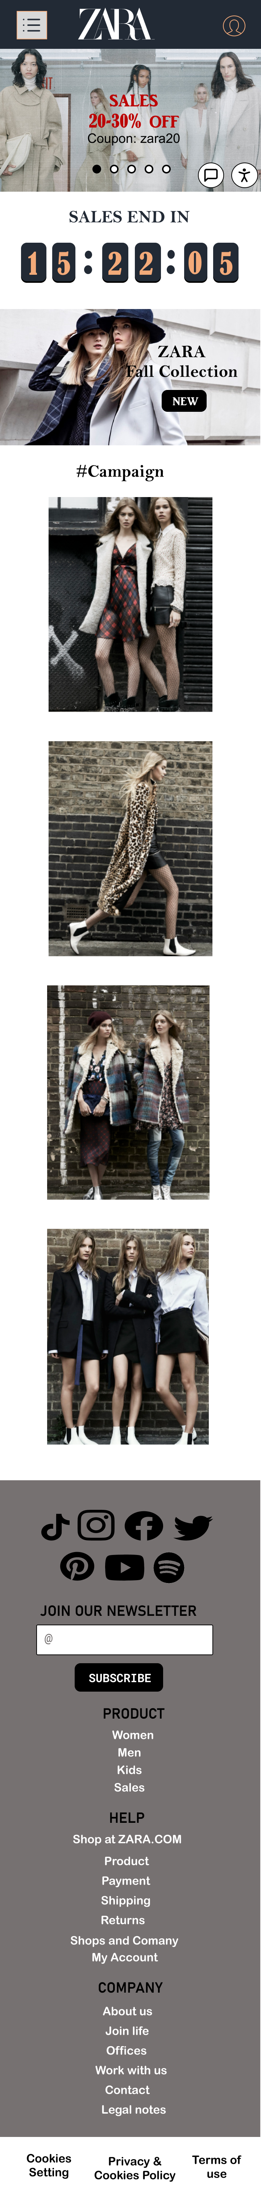

1

3

5

4

6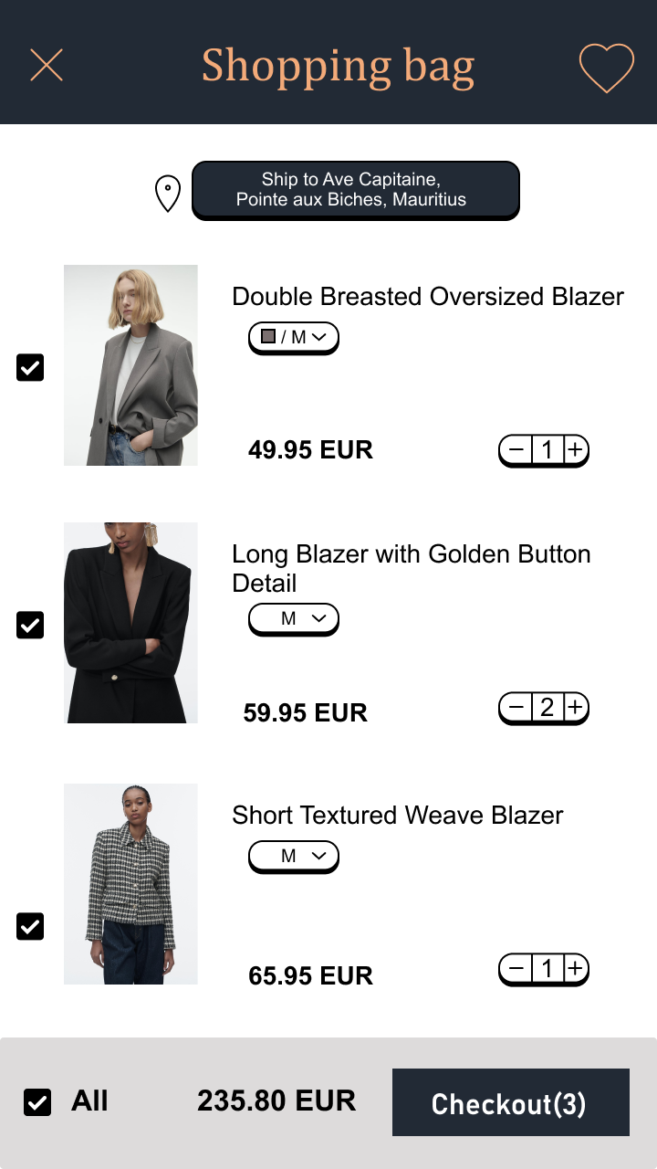

2

## **Navigation Mockup (Desktop and Mobile phone)**

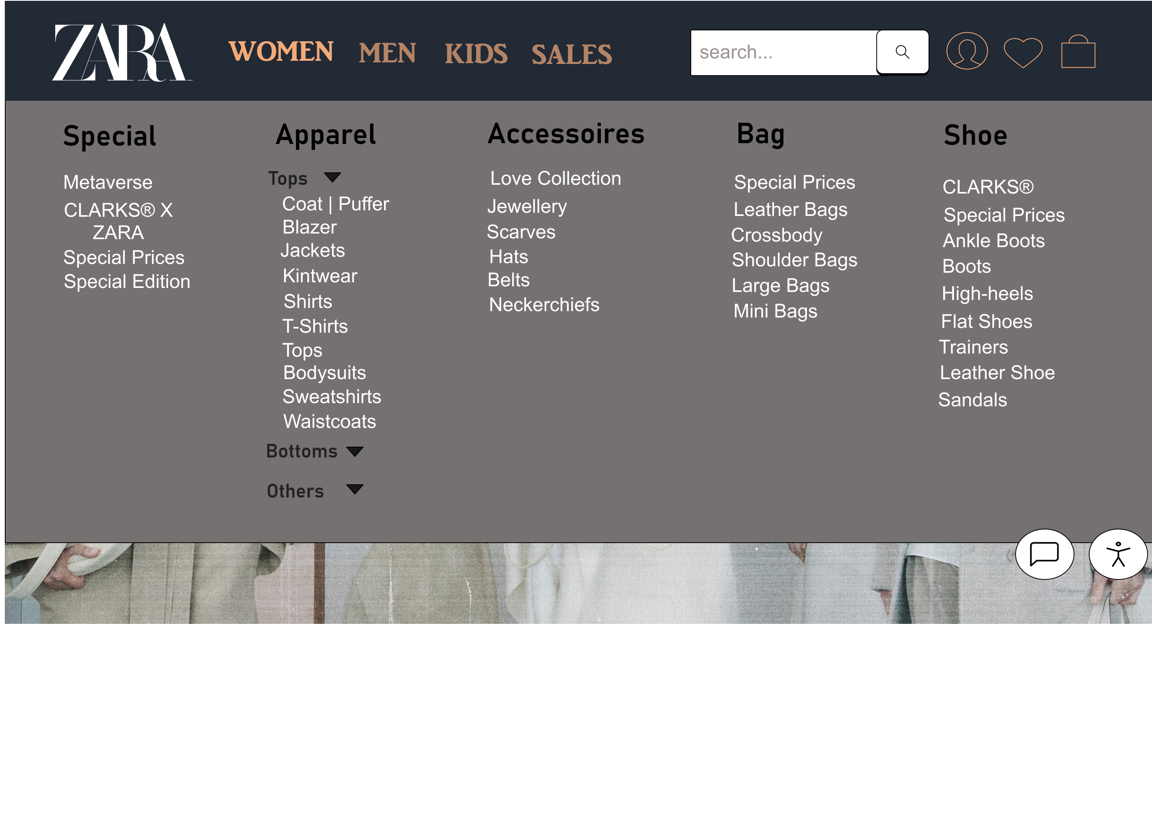

7

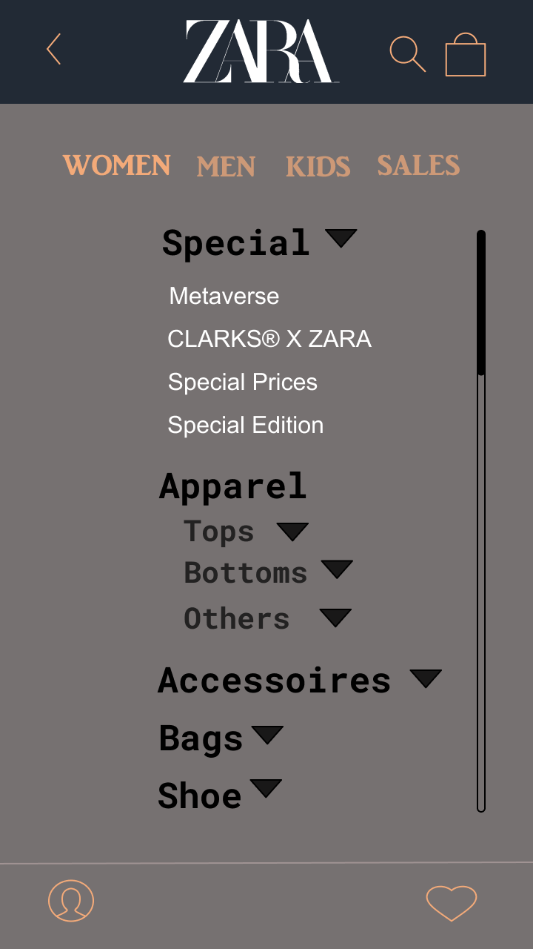

8

## **Product page Mockup (Desktop & Mobile)**

12

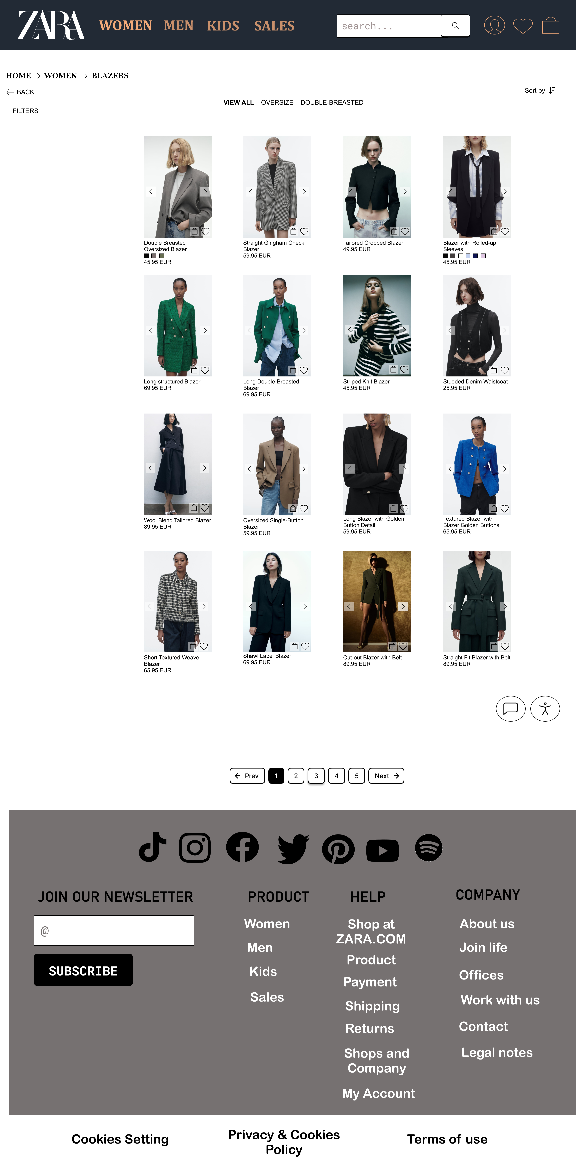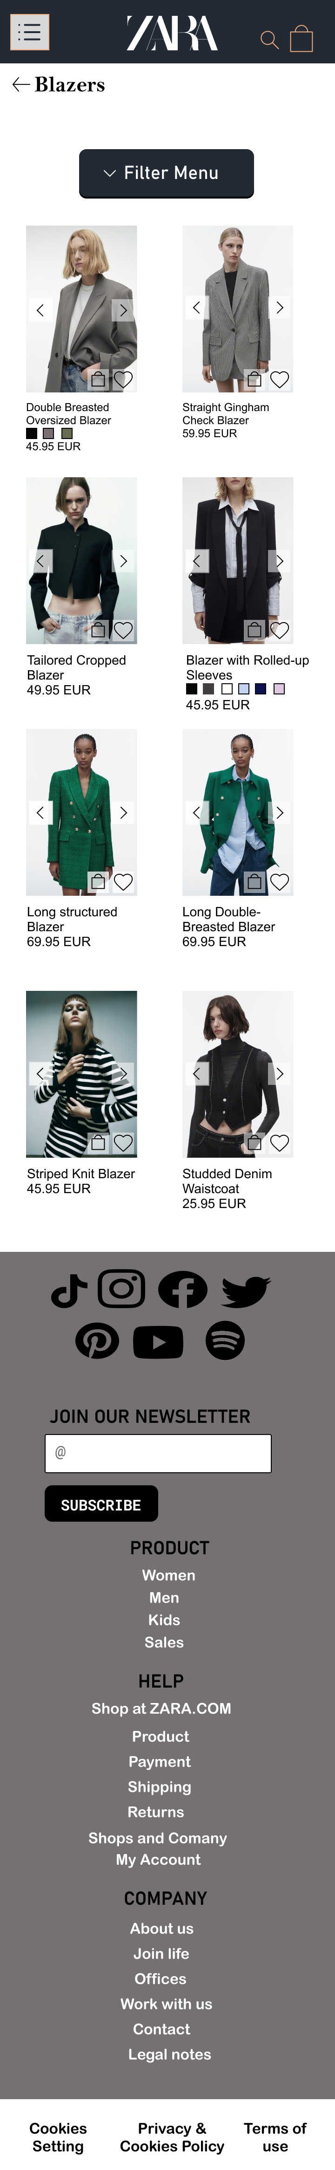

15

14

13

11

100n0x0

9

8

7

6

3

2

1

5

4

## **Cart Mockup (Desktop & Mobile)**

2

7

1

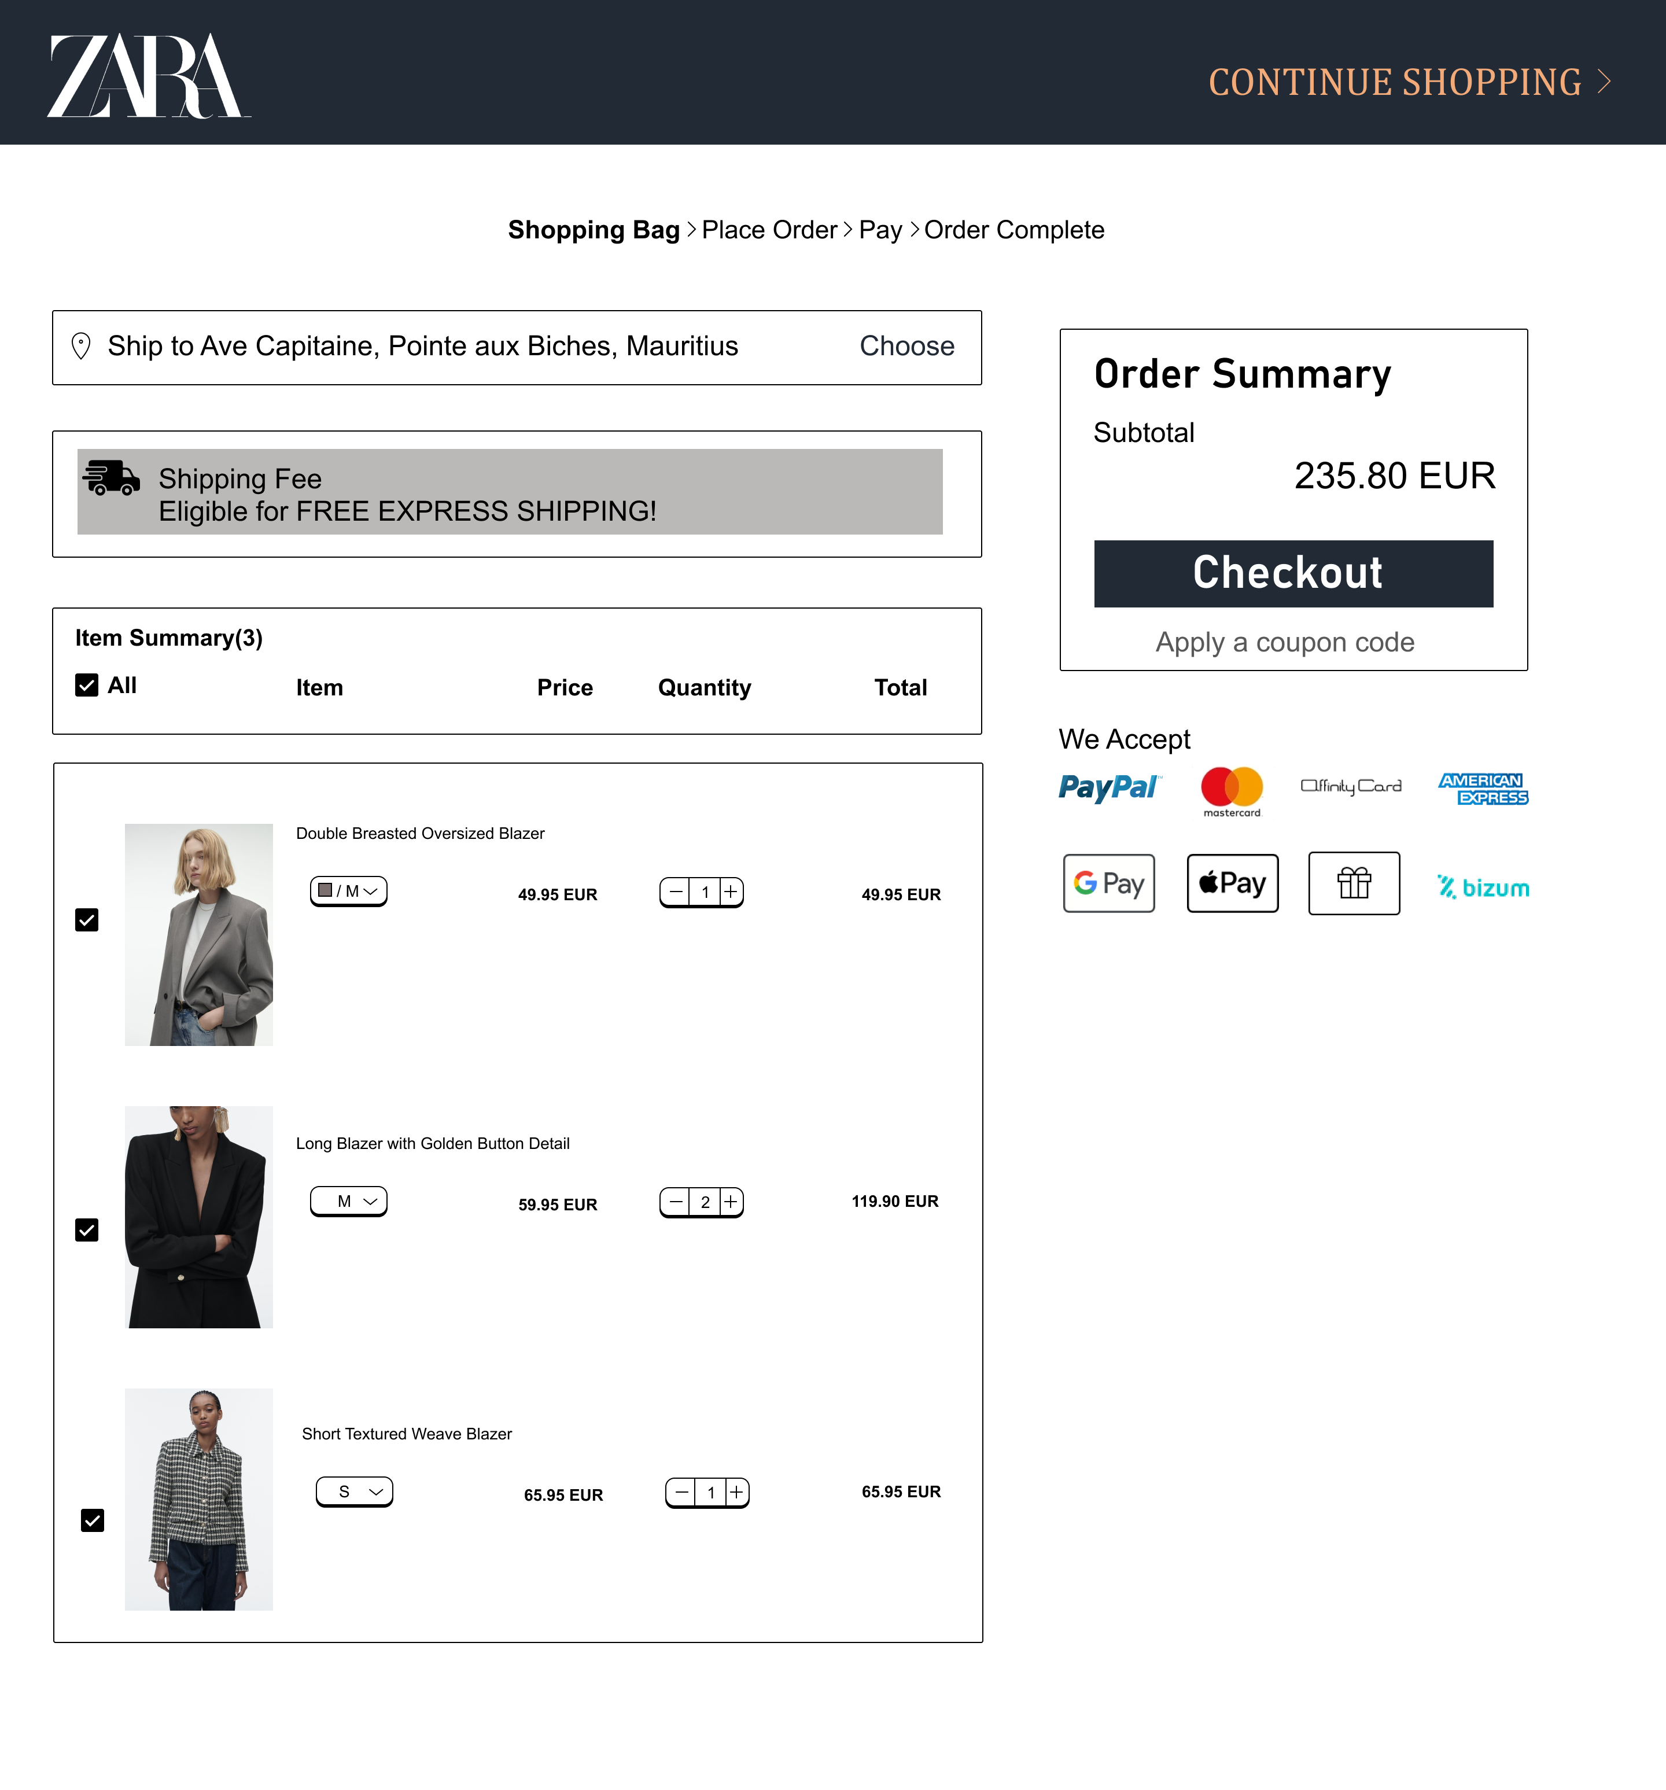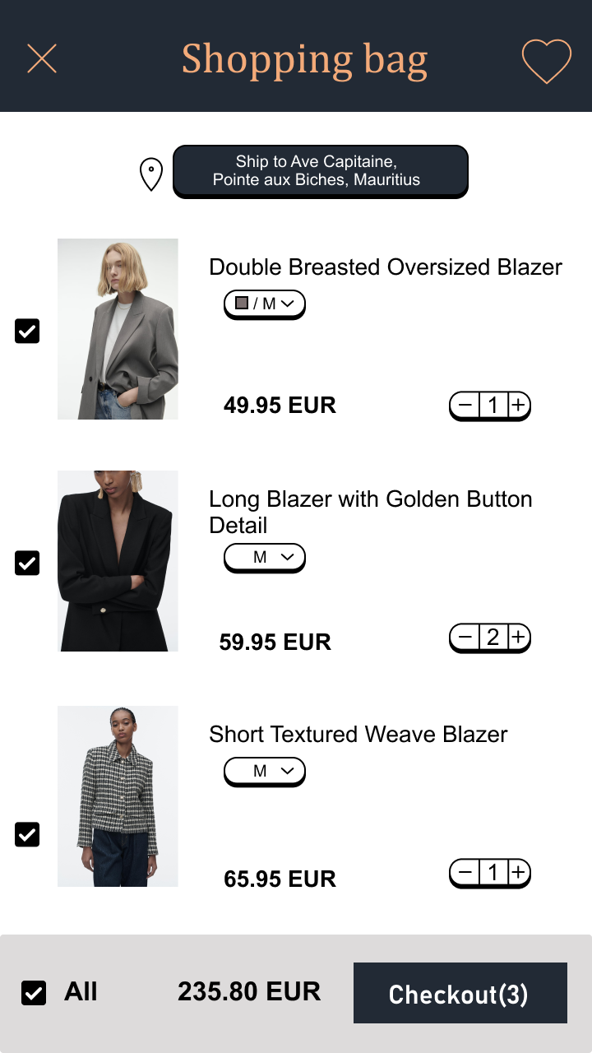

4

3

6

5

8

9

## **View Product page Mockup (Desktop & Mobile)**

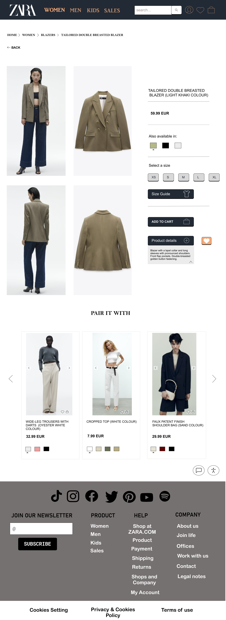 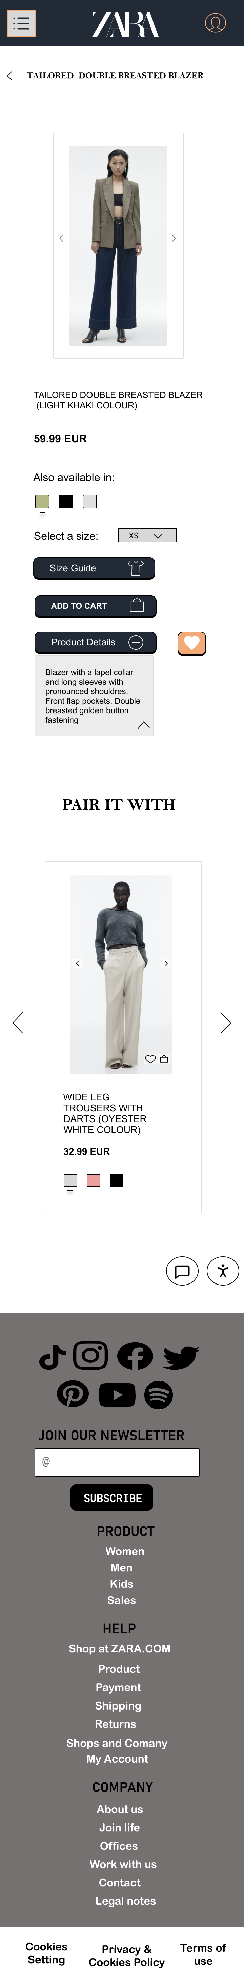

6

5

7

3

4

2

1

# Usability Principles

**How the application is easy to use compared to before redesigning?**

## **Homepage**

**Color theory** – According to the survey made and the response we got from the participants most of them mention they want a blue homepage. So, using the complementary colors ocean blue and apricot from the color wheel, we design the navigation bar taking these complementary colors into consideration. The color blue gives customers an impression of inner security and as for the color apricot it has a positive energetic vibe which draw users attention to call to action such as profile, cart and Wishlist.

Moreover, we added a little bit of gray to create a balancing and calming effect as well as to give it the sophisticated ZARA aesthetic.

1. **Navigation bar** – We made the navigation bar fix to avoid the links in the navbar from overlapping the content and images on the page which was very disturbing for customers while scrolling down the pages.

According to Miller's Lawarranging content into smaller chunks so that users do not have to memorize anything we kept the items in the navigation bar to a minimum by listing the 4 main categories of ZARA’s products. Search bar has been made more prominent to encourage quicker searching of products. The navbar consists of the most common and important elements that a user is going to use most of the time.

Abiding by Jakob’s Law users often users’ application which are similar to other websites therefore we design have design a navbar which users are familiar with for example the cart icon, user know if they click on this they are directed to their shopping cart.

1. **Font Styling** – A red highlight color has been introduced to lay emphasis on the important elements on the page such as sales we used the color red and a different font weight to grab the attention of the users as red is very eye catching.
2. **Carousel** – We added a carousel to display the photography and styling options of ZARA clothes.
3. **Icon** – We provided Accessibility and Customer Service shortcut for frequent users to make users life easy and fast on the website.
4. **CTA** – We added a shortcut for Zara fall collection, when the user clicks on the new button the user is directed to the fall collection page.
5. **Footer** – The footer is added to every single page on the website. It contains quick links that users might want to check out such as if a user need to return an item, they can directly click on returns to know more how to proceed or if they want to go to men section they can directly click on category men rather than going back to the homepage. It saves user’s time. Otherwise, the footer consists of the least important features such as cookies setting, privacy and cookies policies as well as terms of use which are links that are barely used by users that why we put them on the bottom of page.
6. **Category links** –Hick’s Law states that the greater the number of choices, the longer it takes to make a decision so we categories the product into sub-categories to make everything clear and avoid overwhelming users. Unlike how it was before when the user deals with such interface to search something the user will feel lost because everything is clustered together.
7. **Back button** – It permits easy reversal of actions. For instance, if a first-time user is using the ZARA website, they might hesitate to go on a page and cannot revert back hence adding a back button it will help user go back to the initial page without any issue.

## **Product Page**

**1) Header -** Zara logo overlapped the content and navigation menu was hiding. Putting the header this way gives a better definition of all categories and it makes sure no content is hidden.

**2) Category header -** We added the category header, so users know where they are on the website, and they can make use of backward steps instead of undoing and redoing previous actions.

**3) Filter menu -** Filters menu covers the content which can be annoying for users. We added it to the left without it covering any content.

**4) Middle header -** The header in the middle blended in with content of products listing, covering images and texts, however, it is fixed on the webpage.

**5) Sort functionality** - We also added a sort functionality so user can navigate more effectively that doesn’t exist in the existing website. The sort functionality consist sorting products in alphabetical order and prices ranges.

**6) Cart and Wishlist icon -** We also added the shopping bag and favourite icon inside the image placeholder directly instead of clicking on the “+” icon.

**7) Texts and product colour -** When users zoom on the website the images stay the same while the texts decreases. I increased the texts size, made it non editable and added product colors. They are aligned with the images.

**8) Carousel -** The user cannot swipe through different photos of a product but instead must click directly on the product to be taken to a separate page and from there view multiple pictures by scrolling up and down therefore I added multiple product shots in carousel format.

**9) Images -** Varying image sizes and placement are impossible for the user to view the page. I then set the default view to 4 items per row with the right distance used.

**10) Pagination -** Pagination at the bottom of the page is to show users their path on how they got to where they are currently and they can also jump to any pages they want. They do not have to keep scrolling as in the existing system.

**11) Chat box -** Chat box added next to accessibility to be visible instead of people searching for it.

**12) Mobile back button -** We have a back button to allow user to go back to their previous action.

**13) Mobile header icon -** On the mobile app we added shopping bag and search icon on header so users can have easier access.

**14) Mobile filter menu -** Filter menu is in the middle as it is one of the important steps when going through a category page.

**15) Mobile images -** Lastly, we added two items per row with proper alignment of texts and images.

## **Cart**

**1) Header -** The header “continue shopping” is added if a user wants to go back to shopping. This header is different from the others as the page is a cart page.

**2) Checkout steps -** Steps of checkout is broken down in four different steps. The prototype of the four steps is not shown completely however you can see the steps as wireframes. In the existing system steps are not shown leaving users confuse as to how many steps they should go through.

**3) Shipping address -** Address is added so users do not have to go back to setting to modify their address. They can also choose their billing and shipping address.

**4) Items summary -** Items bought are resized smaller, so users do not need to scroll to see items summary such as size, quantity, and prices. Also, you can modify those details on the “shopping bag” page.

**5) Order summary -** An order summary is added bigger with the price text visible. In the existing page the texts are small. The total of items should have bigger size as it is important information that should not go unnoticed. After clicking on “Checkout” you go to the next step.

**6) Payment cards -** We added all payments cards that ZARA accepts however the payment will be on another page to prevent customers from being overwhelmed by the amount of information on the page.

**7) Mobile header icon -** On the mobile app we added the Wishlist icon and a cancel button in the header.

**8) Mobile Shipping address** - In the middle of the page we added the shipping address as it is more eye-catching.

**9) Checkout button -** We didn’t add many details in the checkout section for mobile app as we don’t want users to feel confused with lots of information.

## **View Product Page**

1. **Path** –We have included a path which acts as a guide to the users, and they can go back to the previous page whenever they want and also, this way they get a much better understanding of their actions.
2. **Pictures layout** –In the current ZARA website the users are presented with one large picture, and they have to scroll up and down to view the outfits. It can be real nuisance for the users to scroll up and down each time. Hence, we have redesigned this whole situation and displayed 4 - 5 items in which they can click on, and it expands.
3. **Font styling** –We have used a much proper font with more weight. Compared to the website which has used a light grey colored font as a result of making the page boring and quite dormant.
4. **Description box** –We added a description box for the product details, and if ever the user wants to know more information about the product he/she just has to click on the plus sign and it displays the information. Displaying the information this way, makes the website much neater.
5. **Chat box & Accessibility feature** –We made sure that both the chat box and the accessibility feature are fixed, so that they do not overlap with other contents when the user has to scroll.
6. **Wishlist & Cart** –Users can directly add their items to cart / Wishlist , by clicking on the cart / heart icon.
7. **Carousel button** –We have added carousel buttons so that the user can view all pictures related to the product in a single grid.